Greatest Brain: Parallel Computation with Supercomputer
Artificial Intelligence: Economic Central Nervous System
Economic Big Data Analysis • Online Economic Simulation
Innovative Study on Complex System
Guangzhou Milestone Software CO.LTD

Leading in the World
Advanced · Unique · Universal
Digital Economic Simulation Laboratory

INDEX Directory

Product profile

Form & Advantages
Market applications

Product categories
System composition

Functional modules

Experiment process
Application cases

Cooperation

01/12
Product Profile
Product Profile

The experiment of digital economy
simulation is an economics teaching method based on modern computer digital simulation technology. Through the use of modern computer digital simulation technology, this teaching method creates various kinds of digital simulation economic events, leads the students to play a specific economic role, enters the computer virtual economic scene which accords with the teaching plan design, and revolves around the economic events which are visualized in the teaching plan.
Students through the construction of various economic events deductive process, in the day as a unit of continuous economic events change process, experienced computer simulation of the country, industry, enterprises, residents, years to decades of success or failure of honor and disgrace process, understand the true meaning of business decisions, improve strategic management ability. After the end of each year's operation and management, the students reflect on the success or failure of the decision, analyze the strategic gain and loss, comb the management ideas, expose their own misunderstandings, and improve the comprehensive management quality through many exercises of adjustment and improvement.
The full-digital economy simulation teaching experiment is actually an upgraded version of the traditional semi-physical simulation sand table deduction, which inherits the advantages of the traditional sand table deduction experiment mode and overcomes its shortcomings at the same time.

Source
Economic sand table simulation training derived from western military war sand table simulation exercises
The traditional war sand table simulation deduces through the red and blue two armies on the battlefield confrontation and the contest, discovers the two sides strategic tactical existence question, enhances the commander's combat ability. Britain and the United States well-known business schools and management consulting institutions quickly realized that this method is also suitable for enterprises to train and exercise senior managers, and then the military sand table simulation for extensive reference and research. In recent years, with the improvement of computer computing ability, military sand table deduction has developed computer full digital simulation sand table deduction. Now, we will transplant this technology to the economic field, carry on the national economy sand table actual combat simulation training this new modern training model.

Form
02/12
Form & Advantages
Experience Learning by
Computer Simulation Practice
There are two methods to understand the objective world: deduction and induction. Sand table deduction belongs to the latter, which through a large number of experimental cases to obtain economic knowledge, with intuitive, vivid and interesting characteristics. Students in the process of experiential learning of experimental cases, combined with the traditional theoretical teaching methods to obtain knowledge points, theory combined with practice, can improve the efficiency of learning.

Advantages
Realistic, Systematic, Interactive, Interesting, Competitive
Computer digital simulation sand table simulation training has the special advantages of lifelike, systematic, interactive, interesting and competitive, it can arouse students' interest in learning to the maximum extent, make full use of the functions of computer digital simulation technology, implement a series of learning methods, such as theoretical guidance, game interaction, information exchange, experimental operation, summary and improvement, and form a deep memory of the contents learned, and can practice and apply the management ideas and methods learned in practical work. In the sand table simulation training, the middle school students get no longer empty concepts, theories, but extremely valuable theoretical and practical experience and deep-seated interaction, understanding and understanding.

Innovation and progress
Digital simulation, macro-micro integration, global economy, high performance parallel computing, complex system, artificial intelligence
The economic laboratory has the innovative functions of digital continuous process simulation, macro-micro integration, international economic systematization, portalization, high-performance parallel computing of supercomputers and artificial intelligence of complex systems.
- There is no systematic, only special and local scene sand table deduction;
- The simulation process is discretized and can not be deduced continuously by iterative cyclic decision.
- Interactive simulation experiments between different economic subsystems can not be carried out;
- The semi-physical simulation process needs to carry on the man-machine combination economic experiment, is affected by the role-playing subjective factor, is difficult to carry on the objective repetition experiment;
- Each semi-physical simulation experiment needs to consume more capital and human resources, and the experiment cost is high.

03/12
Modeling Theory
Economic Dynamics

Economic dynamics, like the traditional system dynamics, regards the real social economy as a dynamic system. But the economic dynamics system is different from the general physics dynamics system, it is a process affected by the labor production activities of intelligent people. In this process, the production purpose of human labor production activities is to obtain products of utility and use value, also it needs to pay the labor cost. In particular, man has the wisdom of learning by doing. Therefore, we can abstract the process of wealth production into a system of economic dynamics driven by natural force, labor force and labor gravitational force (intelligence force).
Level of economic dynamics :(1) Elements: quantity, quality and time; (2) Unit: consisting of economic elements, Dimensions of functions and variables including natural force, labor force and labor force; (3) Basic concepts: further defined by natural force, labour force and labour force gravity, Including output, demand, labor productivity, consumption utility rate, value, use value, commodity, price, capital, profit, stock, futures, term and other economic concepts and dimensions, Among them, output and demand, labor productivity and consumption utility rate, value and use value are dual relations; (4) Agents: intelligent agents of autonomous decision-making and behaviour, Including residents, businesses, government departments, defined by basic concepts; (5) Primary subsystem: consisting of various economic agents, including the industrial circulation chain formed between various industries and industries; (6) Secondary subsystems of economic relations: consisting of various primary economic subsystems, Including the real economy, virtual economy, micro-economy, macroeconomic subsystem and the general system of national economy; (7) Intermediate economic subsystem of administrative relations, Including the central, provincial, municipal, county-level economic regional subsystem; (8) General global economic system: including the economic subsystems of the countries of the world, and international trade, international finance and international capital markets among the economic subsystems of countries.
The economic dynamics system is a huge system from the bottom up. The mathematical model of the system is a branch of the traditional dynamic model and a scientific logic system with completeness and compatibility. For example, economic dynamics examines the unity of opposites between the labor value and the utility value of commodities, and can explain the economic relationship between the labor value and the utility value of all commodities with a full differential equation, which makes the labor value theory of classical economics and the neoclassical theory of utility value into one. At the same time, the economic dynamics also examines the unity of opposites between equilibrium and non-equilibrium in the process of market commodity supply and demand, and can use the full differential equation to explain all the economic relations between supply and demand equilibrium and supply and demand imbalance, which makes the general equilibrium theory of neoclassical economics and non-equilibrium theory have mutually compatible logical relations.
04/12
Modelling Methods
Trinity of Mechanism-based,
Rule-based and Data-based
Modelling
SED model is built by combining mechanism, rule and data. Mechanism modeling refers to the mathematical model of economic dynamics as the modeling mechanism of computer software model. Based on this, the operating mechanism of the SED model is represented by various mathematical equations with analytical solutions, or functions with continuous numerical solutions (difference equations in computer software). For example, each agent in SED carries out economic activities according to the principle of profit maximization, their formula for calculating commodity prices is the mathematical formula of this type. in this case, the various agents of SED are rational people, all of which govern each special economic behavior of each independent individual according to the principle of optimization. The mechanism model solves the computer simulation problem of the general law of economic system.
SED economic rules are based on the subjective will of the individual. Real economic society is not a complete ideal society, there are many irrational people exist. Therefore, people need to make special rules in various political, economic, local customs, trade rules and religious rules according to the objective existence of irrational people to restrain and regulate the behavior of irrational people. For example, in real life, there are capitalist economic system, socialist economic system, the economic policy of the ruling government dominated by the liberal school, the economic policy of the ruling government dominated by the Keynesian school, and the economic policy of the socialist ruling government with Chinese characteristics. Obviously, economic rules can be made arbitrarily according to the subjective will of the individual. However, the effect of economic rules is not influenced by individual subjective will. Only if the economic rules conform to the objective economic law can the optimal economic effect be achieved.
SED data model is based on the rule of probability statistics. The change law of many subsystems in real economy system is relatively stable. For example, the law of the development of urban transportation system, the law of the development of urban energy supply system, the law of market supply and demand of basic means of living products; the law of cycle change of four seasons climate cycle; the law of human life, old age, illness and death; the law of epidemic situation change, etc. this type of model can be modeled using statistical probability. The model built in this way belongs to the type of recursive function. Modeling is relatively simple, but the recurrent analysis of functions is often required for model calibration.
Establishing computer model by combining mechanism, rules and data is helpful for us to solve the relationship between general simulation and special simulation, so that SED can simulate the change of every economic agent's property every day. If there are correct basic data, the fidelity of the SED model can reach more than 90%.
05/12
Market Applications
Market applications
At present, the world's mainstream application technology is still using transmission
System of semi-physical simulation form of sand table deduction products. The sand table simulation exercise course based on semi-physical simulation is one of the core courses of MBA in Europe and America. Many large and medium-sized enterprises in developed countries, such as Europe, the United States and Japan, regard it as a permanent compulsory course for middle and senior level.China has introduced traditional sand table exercises in recent years .18 institutions of higher learning, such as Peking University, Tsinghua University, Zhejiang University, National People's Congress and Shanghai Jiaotong University, have included a series of sand table simulation training courses in their MBA、EMBA and middle and senior managers' on-the-job training. Experiential training takes sand table simulation as a practical instruction course for many universities and well-known enterprises, and has been popularized in Beijing, Shanghai and Chengdu, China.
Computer digital simulation sand table deduction course is an innovative technology. At present, the technology has been purchased by some national key laboratories of universities in China, and has begun to enter the trial stage. Because the computer digital simulation laboratory product is advanced, unique and universal. At the same time, it is an upgrade product of semi-physical simulation laboratory, which can replace the traditional semi-physical simulation laboratory in an all-round way, and it is estimated that it will be widely used in domestic and foreign markets in the future.

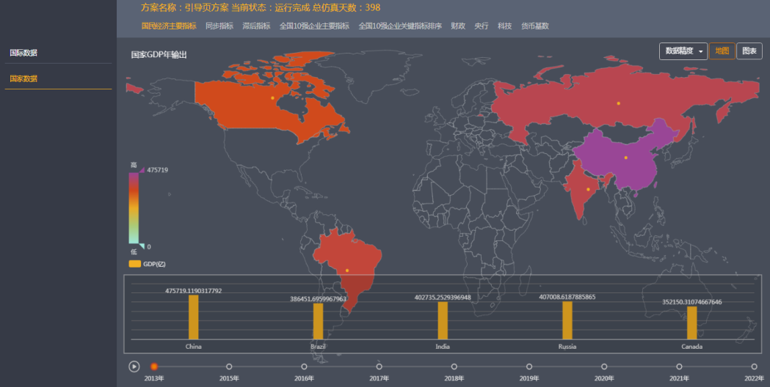

06/12
Type of Products
Type of Products
Traditional semi-physical simulation
sand table products, as needed. With the constant change of demand, a single sand table simulation model can not meet the diversified needs of customers, such as government non-operational institutions, or a single sales new enterprise. So the sand table simulation has developed a more famous scene sand table such as :" Battle of the Sea "," Air hegemony "," World Bank ". There are also many marketing sand tables, such as Excellent Marketing. All kinds of sand tables are widely used in enterprise institutions, in short, a hundred flowers bloom. China's more famous research institutions are Central Europe, happy energy and so on.
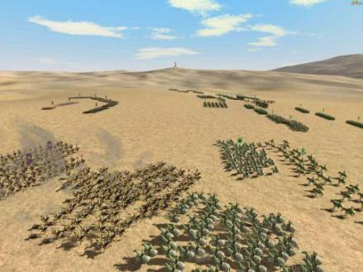

Modern Digital Simulation Products
Education Edition :1 version of the existing national economic model NL_T1.0, including three parts: micro-economic module, macro-economic module and macro-micro-economic integration module, among which the micro-economic module includes consumers and enterprises, enterprises are divided into seven major industries; the macro-economic module is mainly the central government including six major functional departments; The macro-micro-economic integration module is a complete module that integrates micro-economy and macro-economy.each national model in the instructional product supports a simulation scale of 1000 heterogeneous agents.
Scientific research edition: existing national economic model NL_R1.0、 international economic model GL_R1.0、 regional economic model PCS_R1.0, national economy parallel control system Each of these systems and models is a complete system of microeconomic and macroeconomic integration. Based on actual research needs, With different simulation scales, The larger the simulation scale, The smaller the particle size, The more realistic the simulation is, Meanwhile, The more difficult the simulation is. Current support for the simulation scale from the most junior level 1 version, To the top 10, A simulation scale of 1000 heterogeneous agents, Extending to 10 million heterogeneous agents simulation scale, adapt to different scientific research simulation needs.

07/12
System Composition

System Composition
The digital simulation laboratory has constructed an international economic simulation system, which can simulate the economic operation of more than 100 countries around the world, as well as the economic movement process between international trade and international finance among different countries. Each of these countries has sub-modules, such as residents, enterprises, industries, markets, banks, securities, governments and so on, which can simulate the changes in logistics, capital flows and human flows of thousands of residents, seven industries, thousands of enterprises in each industry, each enterprise producing a specific commodity, each commodity having four different grades at the same time.
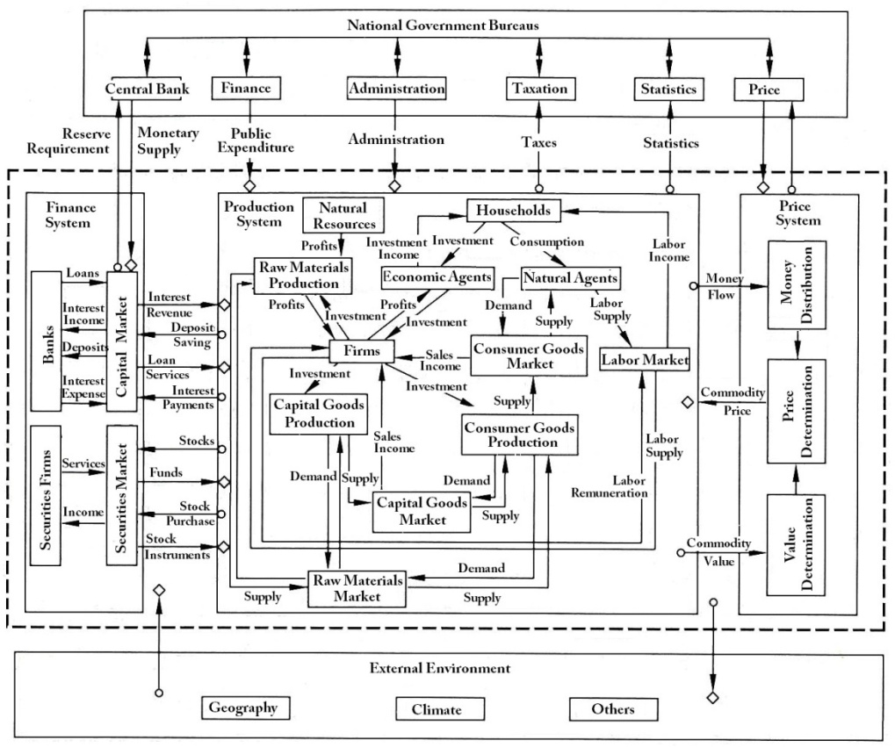
Flow Chart of SED System
08/12
System Composition

System composition
The dynamic simulation system of national economy is composed of residents, enterprises, markets, banks, securities and government subsystems, each subsystem has complete modules and functions.

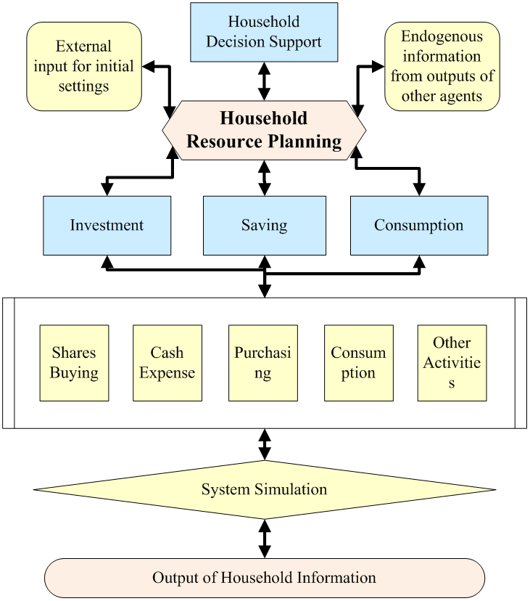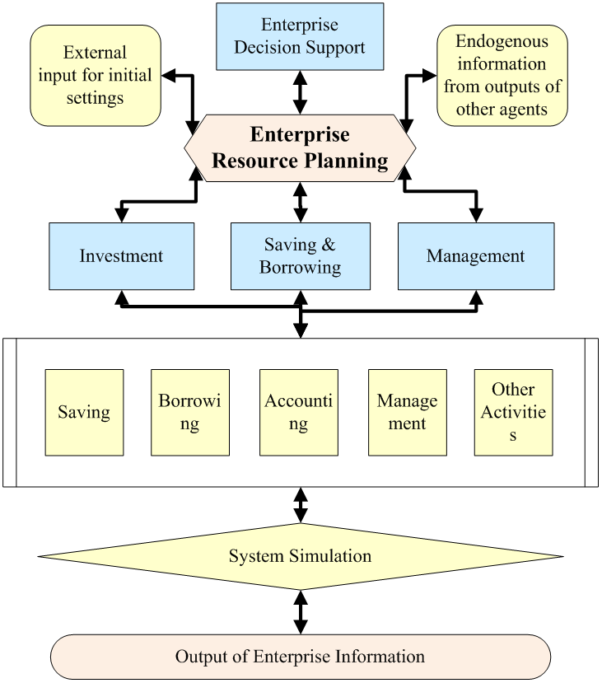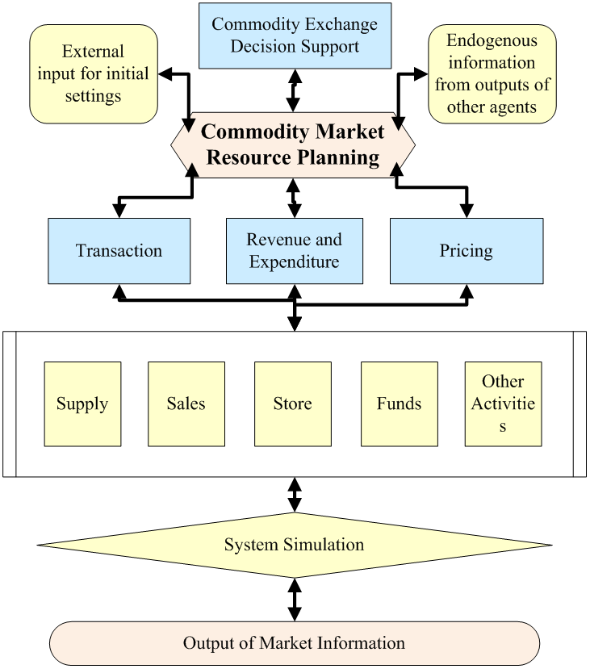
（1）Household （2）Firm （3）Market

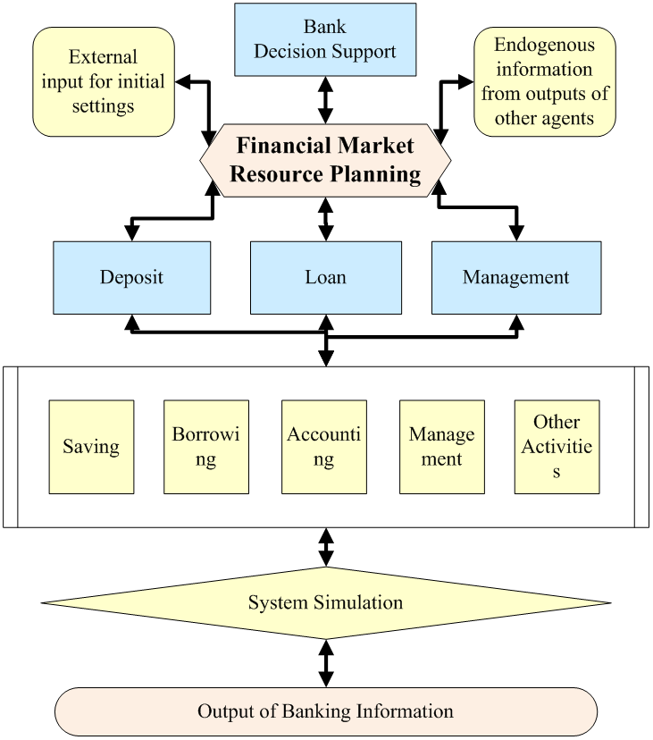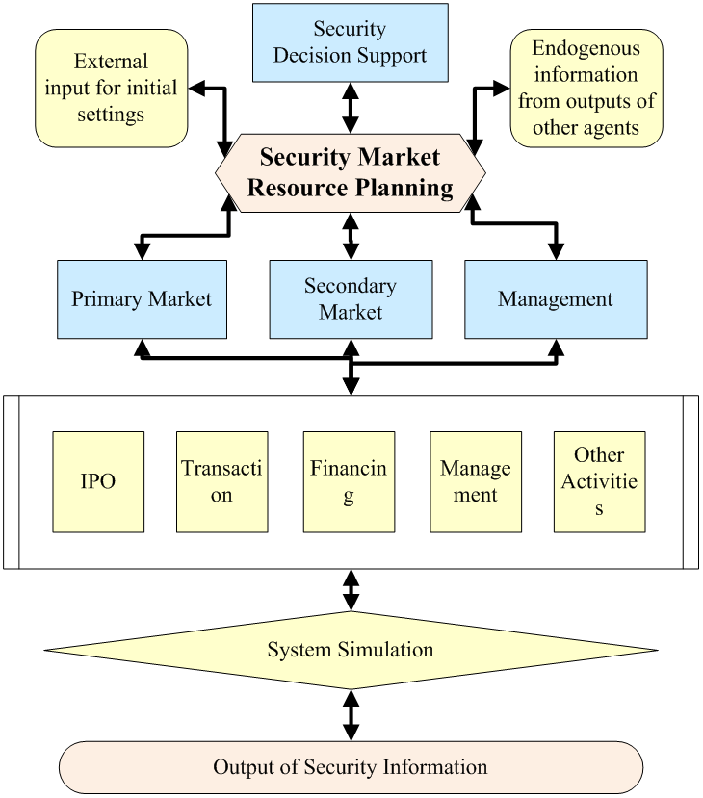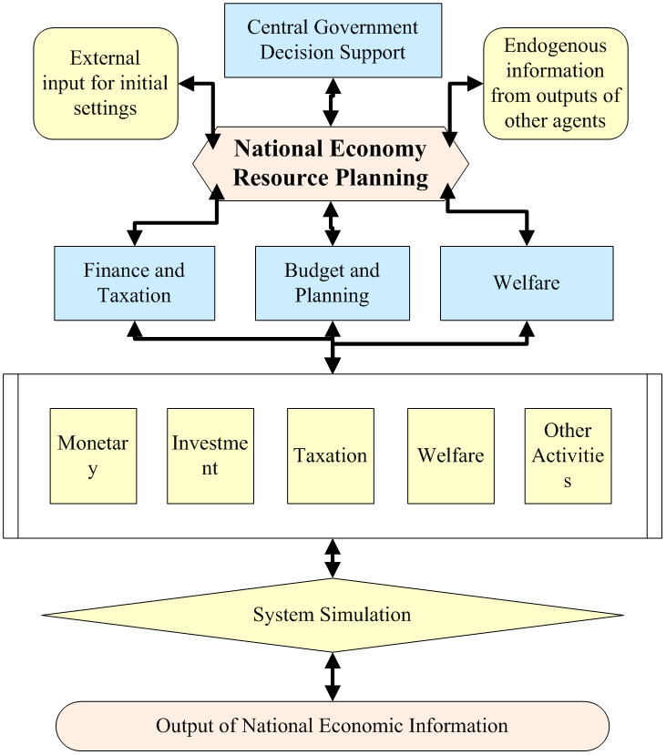
（4）Bank （5）Security （6）Government

09/12
Experiment Process

Target decomposition
The real socio-economic system is a
complex system, and the relationship
between various macroeconomic phenomena and micro-economic events is generally not a simple one-to-one correspondence, but a one-to-many and one-to-many complex relationship, which decomposes the research objectives into various types of economic scenarios according to the economic cycle, product life cycle, industry, scale. In the specific combination of economic scenarios, there are special economic relations and economic movement laws in the economic system. For example, in times of economic crisis, what kind of strategy is needed to operate a technology product in the energy industry at the mature stage of the product, which is different from the operation strategy of the same product life cycle in the same industry in the economic boom period. Subdivision of economic scenarios will help students understand a wealth of economic knowledge and the complexity of real economic systems.

Role selection
The main economic players includes consumers, manufacturers and governments. Under the premise of selecting the economic scenario, the students further select the role to be played, and enter the game experiment of politics and economy and the related market competition experiment. For example, two groups of students selected manufacturers and the government, can be macro-micro economic policy formulation and micro-economic countermeasures game and deduction. For example, if two groups of students choose different enterprises in the same industry respectively, they can make the competitive strategy of pricing, investment and marketing decisions, and carry on the corresponding games.

Target setting
Depending on the selected economic scenario and economic role, participants can further develop economic goals. For example, the government can set medium- and long-term development goals; enterprises can set "stock goals" and "incremental goals "; consumers can set profit goals, etc. The same economic goal would be achieved in different ways in different economic scenarios, the students should make sufficient analysis and research according to the actual situation to formulate reasonable ways. For example, in economic crisis, the government should focus on formulating and stabilizing the national economy, raising welfare subsidies, and taking appropriate measures to expand infrastructure. In an economic boom, the business objectives of enterprises should pay attention to innovation research and make full preparation for the next stage of product upgrading.

Strategies planning
Economic objectives need to be coordinated with specific economic strategies. If students play the role of government, they should adopt various strategies to deal with economic crisis in times of economic crisis, including macroeconomic crisis response strategy, micro-economic crisis response strategy, and crisis management in the economic field, crisis control, crisis communication, crisis response and so on. If the student acts as the business operator, it is necessary to formulate specific business strategies according to the business objectives. For example, marketing strategies include intensive marketing strategies, non-differential marketing strategies and epidemic marketing strategies. For example, the market layout can be a breadth layout, that is, to develop a larger market; it can also be chosen as a deep layout, that is, the

degree of intensive cultivation.Choosing
10/12
Experiment Process
reasonable breadth layout and depth layout
degree will be beneficial to the continuous
growth of product marketing performance.

Planning
On the basis of qualitative management strategy, make economic plan with quantitative nature. For example, the government's five-year development plan; the enterprise's annual business plan, etc.

Decision extrapolation
Through the computer process simulation function, digital simulation laboratory can carry out various economic decision deduction experiments. For example, the central bank has formulated a monetary regulation policy to increase the reserve requirement ratio by two thousandths. Through computer simulation and deduction experiments, the influence of adjusting the reserve requirement ratio on the national economy is calculated in a certain period of time. Because the digital economy simulation laboratory is a macro-micro-integrated system simulation, it is possible to deduce a comprehensive and continuous change of macroeconomic policy in all fields of the whole national economy, including the GDP, unemployment rate of a country, the inflation rate, the price of each product in each industry, and the change of profit margin of each enterprise. This approach can also be applied to industry economy, enterprise economy, and economic decision-making of individual investors.

Teaching Assessment
According to the teaching plan, the teacher assigns the group simulation experiment to the student. After each experiment is finished, each experiment case is graded by the scoring system of the simulation laboratory. The scoring algorithm is given in advance by the product, which is convenient for the teacher to understand the scoring rules. In addition, the scoring system allows teachers to customize algorithms, define specific scoring algorithms and scoring criteria according to different cases, such as selecting scoring knowledge points, increasing the weight of scoring for key knowledge points, and so on. The scoring system includes individual score, group score, class score, grade score, inter-school score, etc. After getting the score, teachers can make teaching and training comments.

Team Competition
Through the Internet portal, senior organizers can organize various economic simulation competitions, including school competitions, inter-school competitions, national competitions, international competitions, etc. Through digital simulation economic competition, can obtain the better teaching, the propaganda, the exchange, the enhancement effect.

11/12
Application Cases

2009-2011
He participated in the research project of the special project of the Ministry of Science and Technology (National Science and Technology (2009)411)," Analysis of the effect of applying the SED model on China's four trillion financial investment in the context of the international financial crisis ", and obtained the high praise of "leading in China and advanced in the world ".

2012-2013
Based on the research project of Guangdong Development and Reform Commission (NDRC)," Application of SED Model Innovation Technology to Establish a Long-term Mechanism of Guangdong Macroeconomic Decision Support System ", the overall economic simulation and prediction of Guangdong Province in 2013 were carried out, which was highly affirmed by experts in related fields.

2014-2017
To undertake the national "13th Five-Year Plan "strategic emerging industries research case" the application of SED models to analyze the impact of strategic emerging industries on the GDP of the central government and some local governments ".

2015-2016
China National Natural Science Foundation of China (NSFC)-Guangdong Joint Fund Supercomputing Science Application Research Project and the National Supercomputing Guangzhou Center supported by the application of Tianhe-2 supercomputer for national economic system large-scale parallel simulation research.

2015-2019
To undertake the Guangdong science and technology project "Tianhe-2 based cloud computing and big data innovation base" construction, responsible for the economic operation of big data cloud computing tasks.

November 2018
Based on the SED model, the Sino-US trade war is simulated with the Central Institute of Economics and Mathematics of the Russian Academy of Sciences, and the Sino-US trade war is simulated and predicted.

12/12
Cooperation

September 2014
As the national simulation control
engineering technology research center Nansha
economic simulation base to undertake the unit, officially unveiled.
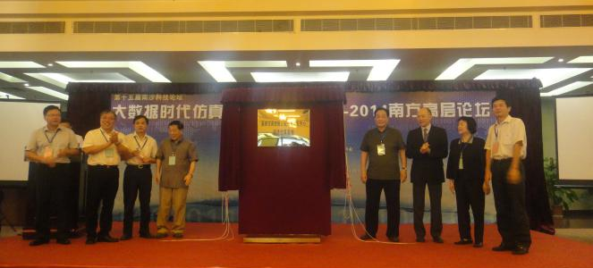

December 2014
A strategic cooperative
relationship was established
with National Supercomputing Guangzhou Center, and the
SED model was successfully transplanted to the Tianhe-2 supercomputer to complete the large-scale parallel simulation experiment.

December 2015
jointly with the national supercomputing guangzhou center and the institute of quantitative economy and technology and economics of the chinese academy of social sciences co-sponsored the "2015 workshop on computational economics simulation and big data analysis based on Agent modeling ", which gathered more than 50 well-known experts and scholars in related fields at home and abroad.
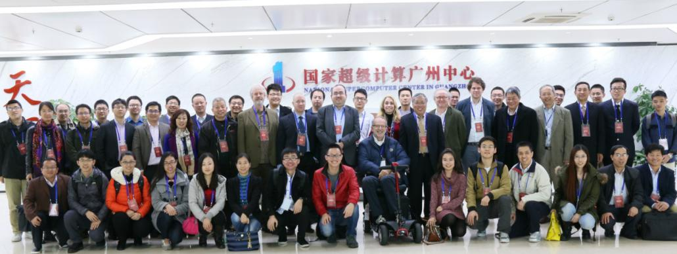

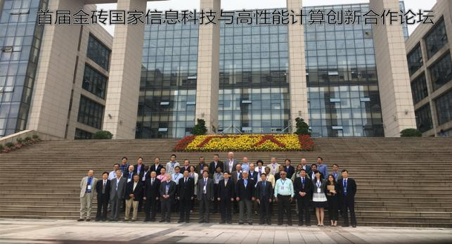
April 2017
Invited to participate in the "first BRICS Information Technology and High Performance Computing Innovation Cooperation Forum" sponsored by the Department of International Cooperation of the Ministry of Science and Technology of the State, co-organized by the Department of Science and Technology of Guangdong Province and the Guangzhou Science and Technology Innovation Commission, and hosted by Guangzhou University.

13/12
Cooperation

October 2017
Invited to participate in the "UNESCO International Centre for Strategic Research and Training in Science and Technology" held in Nansha Information Science and Technology Park, the fifth training, and at the training session introduced the "Supercomputer-based National Economic Intelligent Simulation Center ", highly recognized by the experts.

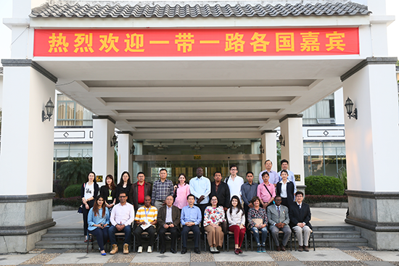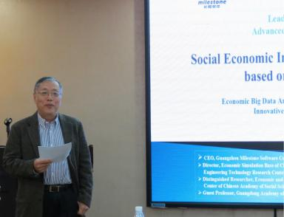

December 2018
To establish a strategic partnership with the Central Institute of Economics and Mathematics of the Russian Academy of Sciences.

January 2019
contract with Guangdong University of Finance and Economics to establish a strategic cooperative relationship.

Milestone of Wisdom, Technology of Future

Economic Fluctuation Monitoring
Economic History Simulation
Economic Theoretical Experiment
Economic Policy Effectiveness Analysis
Economic Optimal Planning
Economic Growth Forecast

Contact Us
Add.: Rm.10B, Tower A, Guangdong International Building,
No.339 Huanshi Dong Road, Guangzhou, China, 510098
Tel.: +86-20-84680993
Fax: +86-20-84680993
Email: info@gzmss.com

